Each artwork must have both labels attached | Attach to Front with masking tape | Name: ①  Title:  Medium:  cut  Sale Price (if not for sale, write NFS): $  Contact phone#:  Email:  cut | Attach to Back/Bottom securely | Name: ②  Title:  Medium:  Sale Price (if not for sale, write NFS): $  Contact phone#:  Email:
Each artwork must have both labels attached | Attach to Front with masking tape | Name: ①  Title:  Medium:  cut  Sale Price (if not for sale, write NFS): $  Contact phone#:  Email:  cut | Attach to Back/Bottom securely | Name: ②  Title:  Medium:  Sale Price (if not for sale, write NFS): $  Contact phone#:  Email:
Each artwork must have both labels attached | Attach to Front with masking tape | Name: ①  Title:  Medium:  cut  Sale Price (if not for sale, write NFS): $  Contact phone#:  Email: | Attach to Back/Bottom securely | Name: ②  Title:  Medium:  Sale Price (if not for sale, write NFS): $  Contact phone#:  Email:
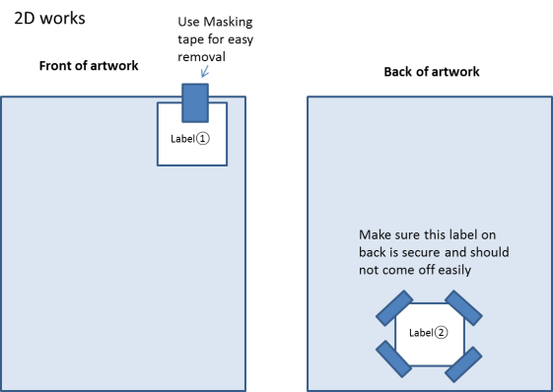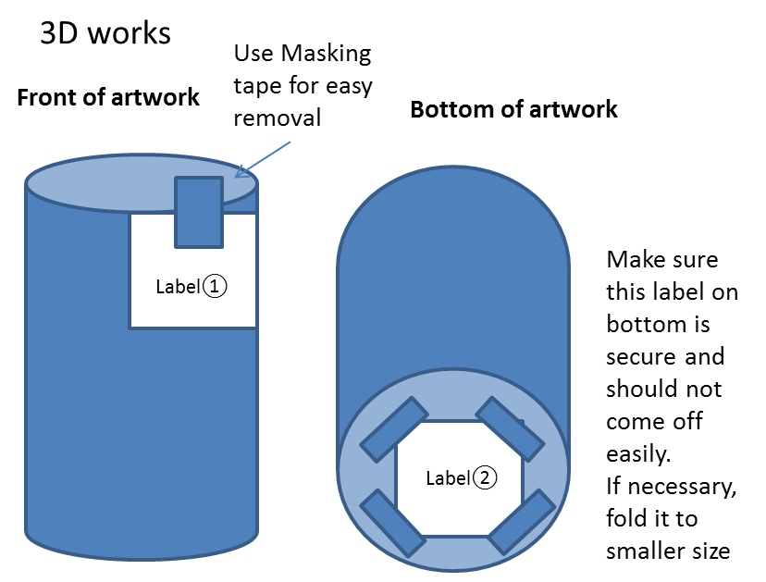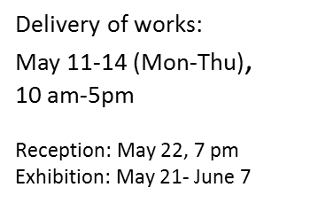
Artist will not be notified if the artworks are accepted. Not accepted: will be notified by email or phone by May 20.
Any work left after May 30 will be discarded.
If works are in the exhibition, pick up works on June 8 & 9, 10-5. Any work left after June 9 will be discarded.

