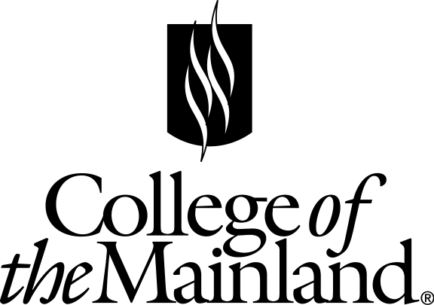
Friendswood High School and College of the Mainland
Dual Credit Registration Guide
For 2017 – 18 School Year
New Student Advisement Session Dates:
January 24, 25 & 31 and
February 1, 2, 7, 14, 15, 21 & 28

All new students must sign up for one session through Naviance. All students interested in dual credit must have an advisement session by March 3, 2017.

- College of the Mainland application through www.applytexas.org. Your Apply Texas
Username _____________________ and Password ____________________
Once you have submitted the application you will receive an Application ID ________________
- It takes 3-5 business days to process the application. You will receive an email will instructions on how to retrieve your COM ID ________________ from College of the Mainland.
- Do you need to submit proof of bacterial meningitis vaccination to COM? YES or NO

- If yes, have you turned that document into a College of the Mainland representative?
  - Date received _______________________ By ______________ (Initials)

- Submit official test scores if you have exemption level scores from SAT or ACT. Please see testing information sheet. These must be official test scores.
  - Date received scores _______________________ By ______________ (Initials)

- Taking the TSI offered by College of the Mainland? YES or NO
If yes, you are signed up to test on the date circled below. See the testing sheet for more information regarding the TSI.
Saturday, March 4, 8 a.m. - 1 p.m. (Learning Center) (No entry after 8:30 a.m.)
Tuesday-Thursday, March 7, 8 & 9 at FHS Computer Room 609
Testing starts promptly at 4 p.m. and ends at 7 p.m. (No entry after 4:30 p.m.)

- Register and pay for your dual credit classes on:
Tuesday, April 25, seniors, or Wednesday, April 26, juniors
In front of FHS Principal’s Conference Room 1:30 until 4:30 p.m.

You must have your signed Dual Credit Enrollment Form in order to register.
Tuition and Fees 2016-2017
- Out of District: $250 for 1-2 classes per semester
- $75 for each additional class
- Online fee $35, hybrid $25
- Books are not included.
- Additional fees for classes may be applied.
Contact Information
dbridges@com.edu
409-933-8679

