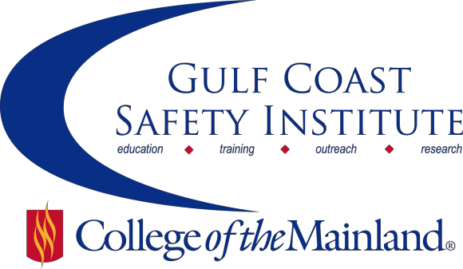
Center for Risk Management
2015 Fall Course Schedule
The Center for Risk Management safety training classes are offered FREE to the public through a generous grant from the Texas Mutual Insurance Company. All courses are scheduled from 8:00 am to 5:00 pm on the dates listed. All dates are on Fridays during the calendar year. Continuing Education Units (CEUs) and certificates will be awarded upon successful completion of each course. All classes will be held at the Gulf Coast Safety Institute.*

You can visit www.com.edu/rmi for the registration form. For more information, call 409-933-8365 or email riskmanagement@com.edu.

PERSONAL PROTECTIVE EQUIPMENT-8HRS
This course covers types, selection, maintenance, and care of personal protective equipment in the workplace. The content in this course is designed to comply with the intent of the applicable regulatory requirements. Learner objectives are to: describe the proper use of the various types of PPE commonly found in general industry, identify the level of protection that a user is provided when wearing specific types of PPE, and discuss the general maintenance and care techniques used for various types of PPE.
SAFE-SYN-OSHT-1071-116CL 08/21/15 GCSI Rm 112/114 B. Young

INTRODUCTION TO ENVIRONMENTAL REGULATIONS -8HRS
This course will cover some of the basic concepts of a few of the core environmental regulations such as the Clean Air Act (CAA), Clean Water Act (CWA), Comprehensive Environmental Response Compensation and Liability Act (CERCLA or Superfund), Emergency Planning and Community Right to Know Act (EPCRA), Resource Conservation and Recovery Act (RCRA), Safe Drinking Water Act (SDWA) and Toxic Substances Control Act (TSCA).
SAFE-SYN-OSHT-1071-117CL 09/11/15 GCSI Rm 112/114 S. Laughlin

CONFINED SPACES IN CONSTRUCTION-8HRS
OSHA issued the Confined Spaces in Construction final rule on May 4, 2015. The rule provides construction workers with protections similar to those manufacturing and general industry workers but with some differences tailored to the construction industry. This course will review the requirements in the new standard of ensuring that multiple employers share vital safety information, continuously monitor hazards, and some of the other differences between the General Industry and Construction standards. Compliance with the new standard, including the training components, will also be covered.
SAFE-SYN-OSHT-1071-CL 09/18/15 GCSI Rm 112/114 G. Smith

INTRODUCTION TO PROCESS SAFETY MANAGEMENT-8HRS
Process Safety Management requires a systematic, comprehensive management program that integrates technologies, procedures and management practices to evaluate the risk that chemical process present. This course will cover the elements of process safety management found in OSHA 29 CFR 1910.119.
SAFE-SYN-OSHT-1071-118CL 09/25/15 GCSI Rm 112/114 S. Jackson

ACCIDENT INVESTIGATION-8HRS
In this course students will gain a better understanding of the theory of accidents, including the domino theory and multiple causation, the use of interview techniques to collect data, how to determine causal factors and recommendations, perform an events/causal factors analysis and cause and effect charts.
SAFE-SYN-OSHT-1071-119CL 10/09/15 GCSI Rm 112/114 S. Walker

ORGANIZATIONAL CHALLENGES AND TACTICS FOR SAFETY COMMUNICATION-8HRS
Safety doesn’t have to be all about costly investments in detailed procedures, protective measures, and equipment. Much of what makes for an effective safety and health program is communicating and collaborating with co-workers to understand workplace threats and actively seek safer ways of doing business. This course will explore the challenges facing leaders and safety and health representatives to address organizational issues affecting the work environment. Specifically we will review conditions that promote risk and how to recognize and confront organizational barriers and at-risk behaviors. We will explore methods for communicating with employees and leaders in an effective manner to positively influence safety. And we will offer practical approaches for making decisions associated with safety and managing risk.
SAFE-SYN-OSHT-1071-120CL 10/23/15 GCSI Rm 112/114 D. Loyd

SURVIVING VIOLENT ENCOUNTERS-8HRS
"This course helps anyone with an interest in their personal safety, develop a clear understanding of what the five basic indicators are that may lead to violent encounters, and what one needs to do in order to survive one. Many people believe that violent encounters only happen to others. The simple truth is that all of us should have a plan for encountering random violence. Certain factors, processes, and interactions place certain people at an increased risk for violent encounters. Besides the general public, Human Resource employees, Chemical Plant employees, Oil & Gas Employees, Healthcare employees, Public Safety employees and Correctional officers all have a higher risk of being attacked. This thought-provoking class, consisting of practice drills with real-life scenarios, is a must-have as we find ourselves navigating the turbulent whitewater of present day conflict.
SAFE-SYN-OSHT-1071-121CL 11/06/15 GCSI Rm 112/114 P. Harrell

HOW TO IMPROVE YOUR COMPANY’S DRIVER SAFETY PROGRAM-8HRS
Are you looking for ways to improve your company's driving record? Come join as we examine current safety issues in detail. This includes among other topics: road rage, DUI, driving sideways (aka zigzagging), speeding, texting while driving and the use of other electronic devices, various traffic violations, hot pursuits by law enforcement, various roadway hazards like debris, animals, natural elements such as rain; snow/ice; flooding, construction work on roadways, and vehicle inspection. The goal of this course is to raise awareness of these safety concerns and improve the safety of motorists on highways.
SAFE-SYN-OSHT-1071-122CL 11/20/15 GCSI Rm 112/114 A. Kuzmar

FOCUS ON SAFETY TO INCREASE PROFITABILITY-8HRS
As we grow in an ever changing world, we are eluded by industry’s ability to understand safety’s role in correlation with productivity and quality to increase profit. This class will focus on the importance and dependency of the relationship between the three. After completion of the class participants will be able to recognize and implement key drivers linking Safety, Quality, and Production that will directly increase or decrease profitability.
SAFE-SYN-OSHT-1071-123CL 12/04/15 GCSI Rm 112/114 C. Rosier

*Gulf Coast Safety Institute

320 Delany Rd
La Marque, TX 77568 (409)933-8365
www.com.edu/gcsi

