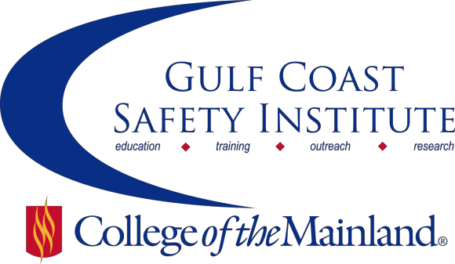

Center for Risk Management
2015 Course Schedule
The Center for Risk Management safety training classes are offered FREE to the public through a generous grant from the Texas Mutual Insurance Company. All courses are scheduled from 8:00 am to 5:00 pm on the dates listed. All dates are on Fridays during the calendar year. Continuing Education Units (CEUs) and certificates will be awarded upon successful completion of each course. All classes will be held at the Gulf Coast Safety Institute.*

You can visit www.com.edu/rmi for the registration form. For more information, call 409-933-8365 or email riskmanagement@com.edu.

OSHA RECORDKEEPING-8HRS
In this course we’ll review the requirements for recording injuries or illnesses on your OSHA Log 300 through case studies and a workshop where you’ll get to improve your skills in identifying recordable incidents.
SAFE-SYN-OSHT-1071-101CL 01/16/15 GSCI Rm 112/114 C. Lewis
SAFE-SYN-OSHT-1071-102CL 01/23/15 GSCI Rm 112/114 C. Lewis

GENDER CULTURE &COMMUNICATION-8HRS
We strive daily in our work and home arena to communicate effectively. Many times cultural and gender issues come into play, and we ignore the obvious. We forget that there are differences in the way we talk to each other. This class illuminates areas that heighten communication across culture and gender. We will cover the difference between 'report' vs. 'rapport' conversations, the best time to talk about cultural hot button issues, whether multi-tasking is only for one gender, and much more. We will take a fresh look at closing the communication gaps across gender and culture. This class is appropriate for any employee – especially those in safety who have to communicate with many people each and every day.
SAFE-SYN-OSHT-1071-103CL 02/06/15 GSCI Rm 112/114 P. Harrell

CREATE & MAINTAIN AN EFFECTIVE FALL PROTECTION PROGRAM-8HRS
Learning how to minimize the risk of potentially dangerous or fatal fall hazards allows an organization to take a proactive approach to worker safety. This workshop provides an overview of effective fall protection programs, giving participants proven strategies for identifying, evaluating and controlling fall hazards. Beginning with background on current fall protection standards, regulations, statistics and trends, the workshop will provide information about all critical elements of a fall protection program. General information about fall protection equipment will also be provided, including equipment components, system development, anchorages, and clearance requirements. All information presented will be in accordance with the ANSI Z359 family of fall protection standards.
SAFE-SYN-OSHT-1071-104CL 02/20/15 GSCI Rm 112/114 N. Miller

ISO 45001: OCCUPATIONAL SAFETY & HEALTH MANAGEMENT SYSTEMS-8HRS
This course will describe the ISO 45001 (Occupational Safety and Health Management Systems) a standard that is currently being developed by an international committee (PC-283) previews the content of the early drafts of the standard and how it might compare to existing international standards and US consensus standards. An overview of the ISO standards development process and the projected schedule for the completion of the ISO 45001 will be presented as a well.
SAFE-SYN-OSHT-1071-105CL 03/06/15 GSCI Rm 112/114 M. Seymour

NFPA 70E – 2015 UPDATES-8HRS
This class will walk learners through an overview of the recent changes in NFPA-70E 2015 and provide an explanation on how they affect the employer and employee. We will also take a look at the recent changes in OSHA 29CFR1910.269 and discuss the relationship between the two. Learners should expect to leave this class with a better understanding of their responsibilities and how each of these standards can be applied in the workers environment.
SAFE-SYN-OSHT-1071-106CL 03/27/15 GSCI Rm 112/114 K. Kirkpatrick

NATIONAL INCIDENT MANAGEMENT SYSTEM (NIMS) AND INCIDENT COMMAND SYSTEMS OVERVIEW (ICS)-8HRS
This course provides a basic introduction to the National Incident Management System (NIMS) and the Incident Command System (ICS) that can be used during any emergency situation. Participants will be given an overview of the key concepts and principles of NIMS and the history, features and principles, and organizational structure of ICS. This class is for anyone who is involved with emergency planning in their organization.
SAFE-SYN-OSHT-1071-107CL 04/10/15 GSCI Rm 112/114 N. Bender

SAFETY & HEALTH IDEA EXCHANGE-8HRS
The best ideas for improving your safety and health management system, getting employees involved and improving your training usually come from those who have had to do it themselves. This class will give you the chance to brag on your company by sharing a best practice with the other attendees. Come and share, or simply come and listen to gain new ideas. Those that want to share their best practices and ideas should contact SeAlice Hemphill at shemphill@com.edu to sign up.
SAFE-SYN-OSHT-1071-108CL 04/24/15 GSCI Rm 112/114 C. Lewis

IMPROVING YOUR RESPIRATORY PROTECTION PROGRAM-8HRS
Respiratory protection programs are more than just buying respirators and making them available to your workforce. This class will cover the requirements of the OSHA standard, how to develop your respirator cartridge change out schedule, and identify the typical pitfalls that could result in an OSHA citation.
SAFE-SYN-OSHT-1071-109CL 05/08/15 GSCI Rm 112/114 E. Parsons

HAZARD COMMUNICATION-HOW DOES YOUR PROGRAM MEASURE UP-8HRS
The Globally Harmonized System of Classification and Labeling of Chemicals have been in effect for more than a year now in the revised Hazardous Communications (HazCom) standard. Does your HazCom program meet the new OSHA standard and are your employees trained to the new requirements? Come out and learn how your program measures up to the new GHS.
SAFE-SYN-OSHT-1071-110CL 05/29/15 GSCI Rm 112/114 T. Holowaty

*Gulf Coast Safety Institute 320 Delany Rd
La Marque, TX 77568 (409)933-8365
www.com.edu/gcsi

