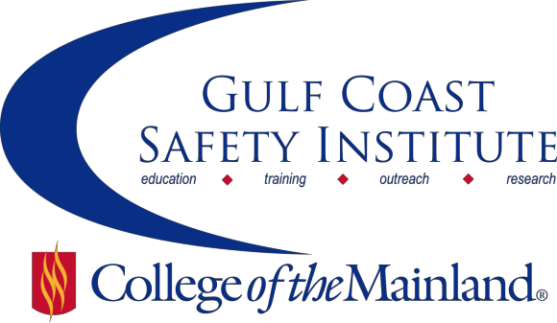

Center for Risk Management
2016 Spring Course Schedule
The Center for Risk Management safety training classes are offered FREE to the public through a generous grant from the Texas Mutual Insurance Company. All courses are scheduled from 8:00 am to 5:00 pm on the dates listed. All dates are on Fridays during the calendar year. Continuing Education Units (CEUs) and certificates will be awarded upon successful completion of each course. All classes will be held at the Gulf Coast Safety Institute.*

You can visit www.com.edu/rmi for the registration form. For more information, call 409-933-8365 or email riskmanagement@com.edu.

OSHA RECORDKEEPING -8HRS
This course will cover a review of the requirements for recording injuries or illnesses on your OSHA Log 300 through case studies and a workshop where you’ll get to improve your skills in identifying recordable incidents. Discussion of the latest updates to the OSHA standard and proposed changes will also be discussed.
SAFE-SYN-OSHT-1071-101CL 01/15/16 GCSI Rm 112/114 C. Lewis
SAFE-SYS-OSHT-1071-102CL 01/22/16 GCSI Rm 112/114 C. Lewis

FOCUS 4 CONSTRUCTION-8HRS
This course provides an introduction to the "Focus 4 Hazards in Construction" - electrocutions, fall from heights, caught in or between, and struck by hazards. This course will provide a variety of construction industry scenarios and workshops for students to learn and apply effective training techniques on the work site.
SAFE-SYN-OSHT-1071-103CL 02/05/16 GCSI Rm 112/114 B. Smith

HEARING CONSERVATION-8HRS
Come learn from a licensed Audiologist the practical approach to controlling noise and hearing conservation in the workplace. In this course we will discuss the principles of noise, noise measurement, engineering controls, in depth analysis of hearing protective devices, and noise measurement equipment. How to determine the average standard threshold shift and temporary and short term shift will also be discussed.
SAFE-SYN-OSHT-1071-104CL 02/19/16 GCSI Rm 112/114 J. Sanders

SAFETY FOR CONFINED SPACE ENTRY-8HRS
This course utilizes the OSHA 29 CFR 1910.146 permit-required confined space standard for general industry to show students how to work in a confined space environment to maximize safety for you and those around you. After completing this course student will be able to: understand the scope and application of OSHA’s confined space entry standards; identify “confined spaces” and determine if they are “permit required”; how to develop and maintain permits; know the responsibilities of entrants; identify when to utilize “Alternate Entry” and “Reclassification” procedures; understand the requirements of “Rescue & Emergency Services” and have a basic knowledge of the general use and limitations of related equipment.
SAFE-SYN-OSHT-1071-105CL 03/04/16 GCSI Rm 112/114 J. Cherry

HEAT STRESS AWARENESS-8HRS
Heat related illnesses have been a focus for OSHA for the past few summers. In this course we will discuss the signs and symptoms of heat related illnesses, how to treat employees who are displaying these signs and symptoms and share best practices for heat safety programs gathered from industries around the Houston area.
SAFE-SYN-OSHT-1071-106CL 04/01/16 GCSI Rm 112/114 C. Lewis

SAFETY AUDITS-8HRS
It is advantageous to the workplace to conduct safety audits. Safety audits are used to identify any suspected problems or to evaluate compliance status. This course is designed to focus on the process of conducting occupational, health, environmental and safety audits. Students will learn the philosophy and purpose behind the auditing process; how to receive and review auditing documentation covered by the Occupational Safety & Health Administration regulations and compliance. Additionally, students will learn how to present and manage information gathered in audits to maximize the benefit of the inspection process and learn how to create and customize audit checklist for their specific industry and job scope.
SAFE-SYN-OSHT-1071-107CL 04/15/16 GCSI Rm 112/114 C. Lewis

HAZARDOUS MATERIAL HANDLING-REGULATIONS NOT USUALLY CONSIDERED-8HRS
Safe storage and handling of hazardous materials are subject to OSHA regulations relative to employee safety, EPA regulations for community safety, NFPA for state and local fire regulations, and the DOT for transportation of hazardous material. The purpose of this class is to provide attendees a totally different view of Hazardous Material Handling. This view will address those regulations not usually considered, but equally important, and will show how proper hazardous material handling plays a very significant role in Homeland Security. At the completion of this training, the attendees will be able to: Explain what a TWIC card is and when it is required; Determine when and where to go to get assistance with developing a Hazardous Materials Security Plan; where to go to ensure your operation is complying with regulations pertaining to shipping; where to look to determine if your operation is handling hazardous materials on the Homeland Security DHS list of Chemicals of Interest or Chemicals of Concern and Determine if you are required to be compliant with International Air Transport Association (IATA) regulations regarding shipping dangerous goods.
SAFE-SYN-OSHT-1071-108CL 05/06/16 GCSI Rm 112/114 J. Christy

SEVERE WEATHER SAFETY-8HRS
Come learn from a Chief Meteorologist how to spot severe weather, including hail, damaging winds, and tornadoes, how to report this to the National Weather Service, and how to be “Stormready”. Participants will gain insight on how to spot severe weather and how to differentiate between severe and non-severe situations. The second portion of the course focuses on preparation for severe weather, safety procedures during severe weather events, and safety hazards during aftermath and recovery. Emphasis is placed on safety in the workplace as well as in the home. The course objective is to increase awareness and knowledge of severe weather in order to decrease the number of injuries and deaths, and where possible to decrease property damage.
SAFE-SYN-OSHT-1071-109CL 05/20/16 GCSI Rm 112/114 B. French

*Gulf Coast Safety Institute

320 Delany Rd
La Marque, TX 77568 (409)933-8365
www.com.edu/gcsi

