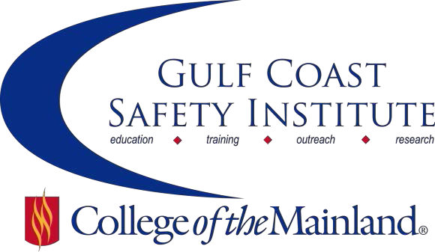

Center for Risk Management
2018 Spring Course Schedule
The Center for Risk Management safety training classes are offered FREE to the public through a generous grant from the Texas Mutual Insurance Company. All courses are scheduled to begin at 8:00 am on the dates listed. Courses are held at the Gulf Coast Safety Institute facility*. All dates are on Fridays unless otherwise listed. Continuing Education Units (CEUs) and certificates will be awarded upon successful completion of each course. For more information, or to register, call 409-933-8365, email riskmanagement@com.edu, or visit www.com.edu/gcsi.

OSHA Recordkeeping– 8 hrs

This course will cover a review of the requirements for recording injuries or illnesses on your OSHA Log 300

through case studies and a workshop where you'll get to improve your skills in identifying recordable incidents.

Discussion of the latest updates to the OSHA standards and the new e-Reporting requirements will be discussed.

SAFE-8558-OSHT-1071-101CL 01/19/18 GCSI Rm 112 C. Lewis

Hearing Conservation – 8 hrs

In this class we will discuss: hearing loss prevention; noise induced hearing loss development and effects; in-depth analysis of hearing protective devices: determining recordability of a STS (Standard Threshold Shift); principles of noise, noise measurement, and engineering controls which includes noise measurement equipment and procedures for measuring noise demonstration.

SAFE-8559-OSHT-1071-102CL 02/02/18 GCSI Rm 112 J. Sanders

Gender Culture & Communication – 8 hrs

We strive daily in our work and home arena to communicate effectively. Many times cultural and gender issues come into play, and we ignore the obvious. We forget that there are differences in the way we talk to each other.

This class illuminate’s areas that heighten communication across culture and gender. We will cover the difference between 'report' vs. 'rapport' conversations, the best time to talk about cultural hot button issues, whether multi-tasking

is only for one gender, and much more. We will take a fresh look at closing the communication gaps across gender and culture. This class is appropriate for any employee - especially those in safety who have to communicate with many people each and every day.

SAFE-8560-OSHT-1071-103CL 02/16/18 GCSI Rm 112 P. Harrell

Successfully Navigating Safety-Related Investigations and Legal Proceedings – 8 hrs

This course is designed to address the legal issues surrounding investigations and legal proceedings. We will generally, use OSHA investigations as the framework but many of the concepts will be applicable to other investigations and litigation generally. Topics to be covered include: the legal rights of employers during investigation and tips for navigating an investigation; how to address problems that arise when contesting an OSHA case; understanding the legal procedures involved in litigating OSHA cases; and, understanding what happens at trial.

SAFE-8561-OSHT-1071-104CL 03/02/18 GCSI Rm 112 M. Deffebach

Regulations, Hierarchies, and Conditioning: The Three Levels of Hazard Controls – 8 hrs

Regardless of the industry, high-reliability hazard control requires more than regulatory compliance. For every hazard, there must be a hazard control. Some of these hazard controls are mandated by federal law or National Consensus Standards. With these regulations as minimal requirements, the Hierarchy of Controls provides a methodology for best practices in finding the most effective hazard controls. However, even with these controls in place, a third tier exists in which employees must be trained and conditioned to identify what these controls are but also when, where and how to use them - in real time. This situational awareness can often be the difference between incidents or a safe work practice, so conditioning to identify hazards in real time, locate and use the proper control is imperative. This conditioning can be accomplished using a 'playbook' approach based on the most effective hazard controls. However, this conditioning is useless without the appropriate regulations, hazard controls and training already in place. Ultimately, these three levels of hazard controls are necessary to create a high-reliability safety culture.

SAFE-8562-OSHT-1071-105CL 03/23/18 GCSI Rm 112 C. Worden

Coaching for Managers and Leaders – 8 hrs

Discover the powerful skills to dramatically improve your ability to influence those you lead to greater results in their business and personal lives. This workshop will equip you with the knowledge and skills to effectively coach others for desired performance. After attending the class, you will be equipped to: summarize the skills of coaching to build stronger relationships with managers and leaders; summarize how to apply the coaching process to influence behavior; and, empower others to sharpen their ability to solve problems and achieve desired results.

SAFE-8563-OSHT-1071-106CL 04/06/18 GCSI Rm 112 D. Baker

Fatigue Management – 8 hrs

Fatigue refers to mental or physical exhaustion that stops a person from being able to function normally. Fatigue causes many accidents when judgment and alertness can be impaired. We must manage this, (not so obvious), hazard! In this class we will look at the seven (7) things to consider when developing a Fatigue Management Plan.

SAFE-8564-OSHT-1071-107CL 04/20/18 GCSI Rm 112 T. Kirkpatrick

Practical Ergonomics for Beginners – 8 hrs

The class will cover musculoskeletal disorders (MSDs) in the workplace and strategies to reduce their incidence.

Students will learn the economic burden of MSDs to their company, and how to "sell" to management the need for a company ergonomics program. The course will address ergonomic hazards in both the office and the plant/field.

After students learn to identify ergonomic hazards, they will learn practical and cost-effective control strategies.

Students will be equipped with the knowledge to develop a company specific ergonomics program and learn how to prioritize their control and prevention strategies.

SAFE-8565-OSHT-1071-108CL 05/04/18 GCSI Rm 112 A. Syverson

Fleet Safety and Vehicle Risk Mitigation (NON-DOT) – 8 hrs

Participants in this course will be able to use the ANSI/ASSE Z15, Safe Practices for Motor Vehicle Operations, to develop a concrete action plan to reduce their drivers' and company's risks, especially pertaining to the risks of non-DOT drivers. This course will also discuss insurance and risk management, driver behavioral motivations, metrics, and partnering with local authorities.

SAFE-8566-OSHT-1071-107CL 05/18/18 GCSI Rm 112 L. McGaha

Gulf Coast Safety Institute * 320 Delany Road La Marque TX 77568 * 409-933-8162

