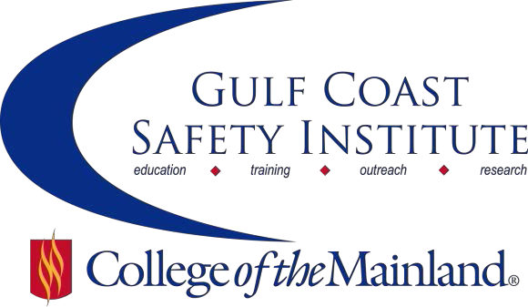

Center for Risk Management
2018 Spring Course Schedule
The Center for Risk Management safety training classes are offered FREE to the public through a generous grant from the Texas Mutual Insurance Company. All courses are scheduled to begin at 8:00 am on the dates listed. Courses are held at the Gulf Coast Safety Institute facility*. All dates are on Fridays during the calendar year unless otherwise listed. Continuing Education Units (CEUs) and certificates will be awarded upon successful completion of each course. For more information, or to register, call 409-933-8365, email riskmanagement@com.edu, or visit www.com.edu/gcsi.

Hearing Conservation – 8 hrs

In this class we will discuss: hearing loss prevention; noise induced hearing loss development and effects; in-depth analysis of hearing protective devices: determining recordability of a STS (Standard Threshold Shift); principles of noise, noise measurement, and engineering controls which includes noise measurement equipment and procedures for measuring noise demonstration.

SAFE-8559-OSHT-1071-102CL 02/02/18 GCSI Rm 112 J. Sanders

Defensive Driving Course 4– 8 hrs

This defensive driving course provides key understanding, skills and techniques to avoid collisions, reduce traffic violations and change driver behaviors and attitudes. Participants will acquire the basic knowledge and techniques to recognize potential hazards and avoid collisions and violations. The course will motivate them to change their behind-the-wheel behaviors and attitudes. Students will learn coping techniques for dealing with speeding, distracted driving, impaired driving, and hazardous traffic conditions and more. The result will be a more responsible driver who understands best practices to prevent injury and death while driving a motor vehicle. Class is limited to 30 students.

SAFE-0579-OSHTX-1071-167CL 02/16/18 GCSI Rm 112 C. Villarreal

Successfully Navigating Safety-Related Investigations and Legal Proceedings – 8 hrs

This course is designed to address the legal issues surrounding investigations and legal proceedings. We will use OSHA investigations as the framework but many of the concepts will be applicable to other investigations and litigation generally. Topics to be covered include: the legal rights of employers during investigation and tips for navigating an investigation; how to address problems that arise when contesting an OSHA case; understanding the legal procedures involved in litigating OSHA cases; and, understanding what happens at trial.

SAFE-8561-OSHT-1071-104CL 03/02/18 GCSI Rm 112 M. Deffebach

Contractor Safety – 8 hrs

Contractor Safety is one of the areas of a safety and health program that can make or break your safety culture. This course will cover the ways in which you can improve your contractor safety program to reduce injuries, improve communication and maintain good client/contractor relations. Topics covered include: contractor selection, on site management and inspections, and contractor removal.

SAFE-0603-OSHT-1071-117CL 03/23/18 GCSI Rm 112 G. Smith

Coaching for Managers and Leaders – 8 hrs

Discover the powerful skills to dramatically improve your ability to influence those you lead to greater results in their business and personal lives. This workshop will equip you with the knowledge and skills to effectively coach others for desired performance. After attending the class, you will be equipped to: summarize the skills of coaching to build stronger relationships with managers and leaders; summarize how to apply the coaching process to influence behavior; and, empower others to sharpen their ability to solve problems and achieve desired results.

SAFE-8563-OSHT-1071-106CL 04/06/18 GCSI Rm 112 D. Baker

Fatigue Management – 8 hrs

Fatigue refers to mental or physical exhaustion that stops a person from being able to function normally. Fatigue causes many accidents when judgment and alertness can be impaired. We must manage this, (not so obvious), hazard! In this class we will look at the seven (7) things to consider when developing a Fatigue Management Plan.

SAFE-8564-OSHT-1071-107CL 04/20/18 GCSI Rm 112 T. Kirkpatrick

Practical Ergonomics for Beginners – 8 hrs

The class will cover musculoskeletal disorders (MSDs) in the workplace and strategies to reduce their incidence.

Students will learn the economic burden of MSDs to their company, and how to "sell" to management the need for a company ergonomics program. The course will address ergonomic hazards in both the office and the plant/field.

After students learn to identify ergonomic hazards, they will learn practical and cost-effective control strategies.

Students will be equipped with the knowledge to develop a company specific ergonomics program and learn how to prioritize their control and prevention strategies.

SAFE-8565-OSHT-1071-108CL 05/04/18 GCSI Rm 112 A. Syverson

Fleet Safety and Vehicle Risk Mitigation (NON-DOT) – 8 hrs

Participants in this course will be able to use the ANSI/ASSE Z15, Safe Practices for Motor Vehicle Operations, to develop a concrete action plan to reduce their drivers' and company's risks, especially pertaining to the risks of non-DOT drivers. This course will also discuss insurance and risk management, driver behavioral motivations, metrics, and partnering with local authorities.

SAFE-8566-OSHT-1071-107CL 05/18/18 GCSI Rm 112 L. McGaha

Gulf Coast Safety Institute * 320 Delany Road La Marque TX 77568 * 409-933-8162

