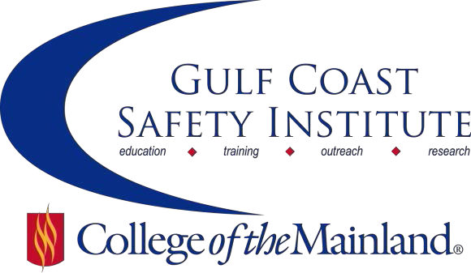

Center for Risk Management
2018 Summer Course Schedule
The Center for Risk Management safety training classes are offered FREE to the public through a generous grant from the Texas Mutual Insurance Company. All courses are scheduled to begin at 8:00 am on the dates listed. Courses are held at the Gulf Coast Safety Institute facility*. All dates are on Fridays during the calendar year unless otherwise listed. Continuing Education Units (CEUs) and certificates will be awarded upon successful completion of each course. For more information, or to register, call 409-933-8365, email riskmanagement@com.edu, or visit www.com.edu/gcsi.

Disaster Preparedness: Lessons Learned from Major Storms Katrina, Rita, and Harvey – 8 hrs

Natural disasters are inevitable. It's impossible to always have the ability to predict an occurrence or an incident. Disaster preparedness is crucial to both safety and emergency management because it saves lives and protects property in these situations. This class provides an overview of the history and science of disasters; major incidence reporting, planning, mitigation, action and the recovery roles of state, federal, local and volunteer organizations. There will also be lessons learned workshops from hurricanes Katrina and Rita, and tropical storm Harvey.

SAFE-0526-OSHT-1071-108CL 06/01/18 GCSI Rm 112 S. Wilson

Organizational Challenges and Tactics for Safety – 8 hrs

Safety doesn’t have to be all about costly investments and detailed procedures, protective measures, and equipment. Much of what makes for an effective safety and health program is communicating and collaborating with co-workers to understand workplace threats and actively seek safer ways of doing business. This course will review conditions that promote risk and how to recognize and confront organizational barriers and at-risk behaviors. We will explore methods for communicating with employees and leaders in an effective manner to positively influence safety.

SAFE-0527-OSHT-1071-109CL 06/15/18 GCSI Rm 112 D. Loyd

Construction Site Safety Awareness – 8 hrs

The construction site is a rapidly evolving work place with a constant need for safety awareness. Knowing the construction codes and regulations, or at least where to find them, is an important part of this awareness. Developing the ability to spot the hidden dangers lurking around the construction site is equally as important and seldom taught. In this class we will explore a variety of subjects related to the modern construction site and help the student to sharpen their eyes and see the hidden dangers.

SAFE-0580-OSHT-1071-115CL 06/29/18 GCSI Rm 112 N. Stuart

How to Create and Manage an Effective Back to Work Program – 8 hrs

Return-to-work programs have traditionally been used to solely reduce worker’s compensation costs. However, return to work programs offer additional benefits such as an improvement in productivity, a boost in employee morale and the prevention of costly turnover within an organization. This course will focus on building effective return-to-work and transitional duty programs.

SAFE-0528-OSHT-1071-110CL 07/13/18 GCSI Rm 112 P. Sandesara

What’s New in Walking Working Surfaces – 8 hrs

Slips, trips, and falls constitute the majority of general industry accidents. They cause 15% of all accidental deaths, and are second only to motor vehicles as a cause of fatalities. The updated OSHA standards for walking and working surfaces apply to all permanent places of employment, except where only domestic, mining, or agricultural work is performed. Upon completion of the lesson, participants will be able to; define the terms: floor hole, floor opening, wall opening, standard railing, and standard toe board, discuss requirements to consider in order to avoid walking/working surface hazards, and follow recommended practices for using ladders and scaffolds.

SAFE-0529-OSHT-1071-111CL 07/27/18 GCSI Rm 112 S. Roberson

Process Safety Management of Highly Hazardous & Explosive Chemicals – 8 hrs

This course will review the history of process safety management (PSM), the importance of PSM and regulatory implications in the United States. Each of the 14 elements will be discussed and examples of compliance provided. The objective of this course is to provide participants with a working knowledge of the PSM framework and some tools to help overcome challenges associated with managing a PSM program.

SAFE-0530-OSHT-1071-112CL 08/10/18 GCSI Rm 112 S. Jackson

Fundamentals of Risk Management – 8 hrs

Risk management is a key component of a successful safety management system. It is required to assess the risks associated with identified hazards. Risk management techniques are used to develop and implement effective mitigation of hazards. In this course, we will learn how to; improve operational safety by correctly identifying hazards, review safety risk management processes, develop and utilize risk management techniques, eliminate or minimize risk; discuss how behavior influences risk vs. rewards.

SAFE-0531-OSHT-1071-113CL 08/24/18 GCSI Rm 112 C. Dillon

Gulf Coast Safety Institute * 320 Delany Road La Marque TX 77568 * 409-933-8162

