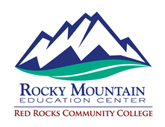
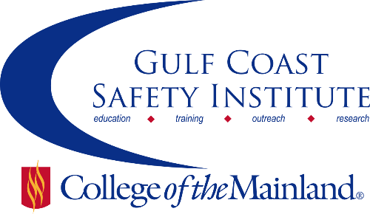

Field Leadership Training Course
Oil & Gas / Construction
Unfortunately, unsafe behavior is a habit that is also contagious. Witnessing an unsafe act can have residual negative impact on fellow workers for up to a week after the event occurred. One worker’s bad behavior can make another more susceptible to forming unsafe habits. Safety habit creation and reinforcement through the skills of the field leaders are critical.
Red Rocks Community College, recipient of an OSHA Susan Harwood Grant, worked with industry partners to develop and deliver a 21-hour course utilizing Social Styles research to enhance good leadership habits for team building, mentoring and conflict resolution.
These courses will be hosted by the Gulf Coast Safety Institute. Attendance in each course is limited to 30 people. Call to reserve your space today!
Oil and Gas Leadership
Monday, February 13 – Wednesday, February 15, 2017
Monday, Tuesday 8:00 am-5:00 pm
Wednesday 8:00 am – 12:00 noon
Construction Leadership
Thursday, February 16 – Friday, February 17, 2017
Thursday, Friday 8:00 am – 5:00 pm
To reserve your space call 409-933-8162 or email gcsi@com.edu

