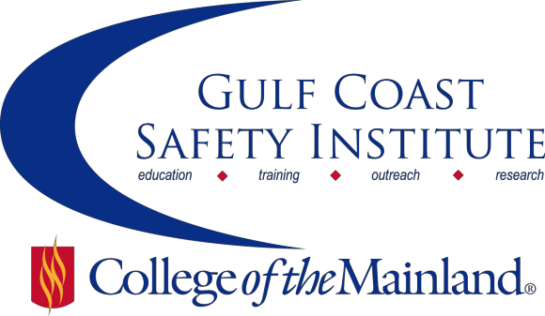

Center for Risk Management
2016 Course Schedule
The Center for Risk Management safety training classes are offered FREE to the public through a generous grant from the Texas Mutual Insurance Company. All courses are scheduled from 8:00 am to 5:00 pm on the dates listed. All dates are on Fridays during the calendar year. Continuing Education Units (CEUs) and certificates will be awarded upon successful completion of each course. All classes will be held at the Gulf Coast Safety Institute.*

You can visit www.com.edu/rmi for the registration form. For more information, call 409-933-8365 or email riskmanagement@com.edu.

INTRODUCTION TO PROCESS SAFETY MANAGEMENT-8HRS
This course will review the history of process safety management (PSM), the importance of PSM and regulatory implications in the United States. Each of the 14 elements of PSM will be discussed and examples of compliance provided. Participants will be encouraged to share their own experiences and ask questions to foster a more active discussion. The objective of this course is to provide participants with a working knowledge of the PSM framework and some tools to help overcome challenges associated with managing a PSM program. Participants will be introduced to resources from OSHA, AICHE, CCPS and other industry leaders. The course will briefly touch on the EPA’s Risk Management Plan requirements.
SAFE-SYN-3863-OSHT-1071-119CL 10/14/16 GCSI Rm 112/115 B. Hamilton

WALKING/WORKING SURFACES-8HRS
Slips, trips, and falls constitute the majority of general industry accidents. They cause 15% of all accidental deaths, and are second only to motor vehicles as a cause of fatalities. The OSHA standards for walking and working surfaces apply to all permanent places of employment, except where only domestic, mining, or agricultural work is performed. Upon completion of the lesson, participants will be able to; define the terms: floor hole, floor opening, wall opening, standard railing, and standard toe board, discuss requirements to consider in order to avoid walking/working surface hazards, and follow recommended practices for using ladders and scaffolds.
SAFE-SYN-3864-OSHT-1071-120CL 10/28/16 GCSI Rm 112/115 G. Njoku

ACCIDENT INVESTIGATION-8HRS
The purpose of this course is to learn about different ways to investigate accidents. You will determine the root causes and develop corrective actions. Participants will use a variety of techniques to analyze accidents and help prevent future accidents from occurring. After completing this course, each student will be able to: Understand the theory of accidents, including the domino theory and multiple causation, use interview techniques to collect data, determine causal factors and recommendations, perform an events/causal factors analysis and cause and effect chart.
SAFE-SYN-3865-OSHT-1071-121CL 11/11/16 GCSI Rm 112/115 J. Oakley

RISK MANAGEMENT FOR SAFETY-8HRS
Safety risk management is a key component of a successful safety management system, required to assess the risks associated with identified hazards, and to develop and implement effective mitigation. In this course we will learn how to; improve operational safety by correctly identifying hazards, review safety risk management processes, develop and utilize risk management techniques, eliminate or minimize risk; discuss how behavior influences risk vs. rewards.
SAFE-SYN-3866-OSHT-1071-122CL 12/02/16 GCSI Rm 112/115 D. Loyd

*Gulf Coast Safety Institute

320 Delany Rd
La Marque, TX 77568 (409)933-8365
www.com.edu/gcsi

