College of the Mainland Email Encryption Guide

Outlook Client
To encrypt an email from the local Outlook client on your computer, click “New Email”
In the New Email window, in the ribbon at the top, click “Options” And then “Encrypt”
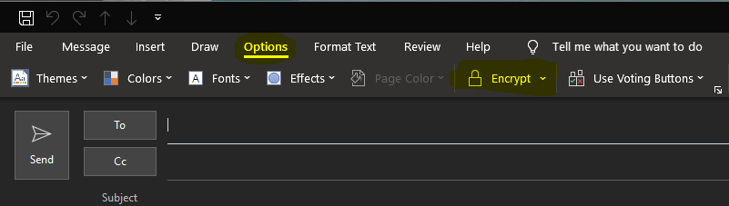
After clicking the Encrypt button, the email will be Encrypt-Only.
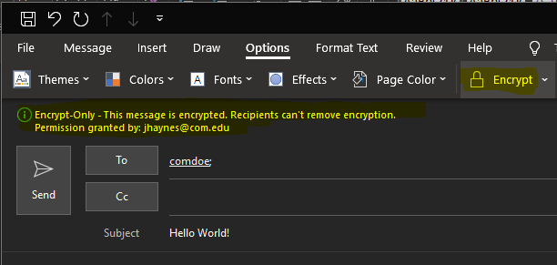
It is important to understand that with the Encrypt-Only option, the email can still be forwarded and viewed by outside individuals. To ensure that the email is encrypted but cannot be forwarded, select “Do Not Forward”
Office 365 Outlook (Internet Browser)
To encrypt an email from the online version of Outlook, click “New Message”
Then, in the message pane, click the ellipses (…) on the right side and a drop down will appear.
Click Encrypt -> Encrypt
