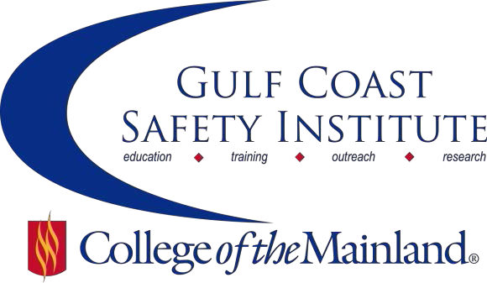

Center for Risk Management
2017 Summer/Fall Course Schedule
The Center for Risk Management safety training classes are offered FREE to the public through a generous grant from the Texas Mutual Insurance Company. All courses are scheduled to begin at 8:00 am on the dates listed. Courses are held at the Gulf Coast Safety Institute facility*. All dates are on Fridays during the calendar year unless otherwise listed. Continuing Education Units (CEUs) and certificates will be awarded upon successful completion of each course. For more information, or to register, call 409-933-8365, email riskmanagement@com.edu, or visit www.com.edu/gcsi.

Bloodborne Pathogens: Disease Transmission Prevention - 4 hrs
Exposure to blood and bodily fluids is quite common in the workplace - not just in the healthcare environment. However, preventing the spread of bloodborne pathogens should be of utmost concern to every worker. This course will provide participants with the knowledge to identify bloodborne pathogens and to protect against exposure. Additionally, we will focus on OSHA requirements in 29 CFR 1910.1030, exposure and health effects, controls and post-exposure actions.
SAFE-8031-OSHTX-1071-117CL 08/04/17 GCSI Rm 112/114 P. Sandesara

Improving Your Respiratory Protection Program - 8 hrs
Respiratory protection programs are more than just buying respirators and making them available to your workforce. This class will cover the requirements of the OSHA standard, how to develop your respirator cartridge change out schedule, and identify the typical pitfalls that could result in an OSHA citation.
SAFE-7958-OSHT-1071-118CL 08/18/17 GCSI Rm 112/114 S. Roberson

Gender Culture and Communciation – 8 hrs

We strive daily in our work and home arena to communicate effectively. Many times cultural and gender issues come into play, and we ignore the obvious. We forget that there are differences in the way we talk to each other. This class illuminates areas that heighten communication across culture and gender. We will cover the difference between 'report' vs. 'rapport' conversations, the best time to talk about cultural hot button issues, whether multi-tasking is only for one gender, and much more. We will take a fresh look at closing the communication gaps across gender and culture. This class is appropriate for any employee – especially those in safety who have to communicate with many people each and every day.
SAFE-8371-OSHT-1071-101CL 09/08/17 GCSI Rm 112/114 P. Harrell

OSHA's Safety and Health Management Guidelines – 8 hrs

OSHA's Safety and Health Program Management Guidelines use a proactive approach to provide employers, workers, and worker representatives with a sound, flexible framework for addressing safety and health issues in diverse workplaces. These guidelines recognize that finding and fixing hazards before they cause injury or illness is a more effective approach. This course will provide an overview of the seven core elements of the Safety and Health Program Management Guidelines. Each core program element outlines steps that employers and workers can take to establish, implement, maintain, and improve their safety and health programs.

SAFE-7562-OSHT-1071-120CL 09/22/17 GCSI Rm 112/114 C. Dillion

Accident Investigation – 8 hrs

The purpose of this course is to learn about different ways to investigate accidents. You will determine the root causes and develop corrective actions. Participants will use a variety of techniques to analyze accidents and help prevent future accidents from occurring. After completing this course, each student will be able to: understand the theory of accidents, including the domino theory and multiple causation, use interview techniques to collect data, determine causal factors and recommendations, perform an events/causal factors analysis and cause and effect chart.

SAFE-7567-OSHT-1071-121CL 10/06/17 GCSI Rm 112/114 J. Oakley

Nuts & Bolts of Industrial Hygiene – 8 hrs

By definition, industrial hygiene is the art and science of the anticipation, recognition, evaluation, communication and control of hazards in the workplace that may result in injury or illness. In practice, industrial hygiene is how we measure whether or not someone might get sick or hurt at their job. This class will cover the fundamentals of industrial hygiene and how to determine what the industrial hygiene program should look like at your facility.

SAFE-7572-OSHT-1071-122CL 10/20/17 GCSI Rm 112/114 T. Holowaty

The Critical Connection Between Safety & Wellness – 8 hrs

There is a direct connection between safety and wellness in the workplace however most companies manage them separately. Lost productivity, accidents, injuries, higher labor and insurance cost all result from not properly connecting safety and wellness. In this class participants will learn how to define workplace illnesses, musculoskeletal disorders/injuries and how they develop, the critical connection between safety and wellness, how to assess your company’s safety and wellness programs, design or modify them to be integrated as one system and discuss the benefits of the program’s effect of the “return on investments” (ROI) such as decreasing employee time away from work, increasing productivity, decreasing time away from work, decreasing healthcare cost and increasing morale.

SAFE-7575-OSHT-1071-123CL 11/03/17 GCSI Rm 112/114 C. Major

Focus on Safety to Improve Profitability – 8 hrs

As we grow in an ever changing world, we are eluded by industry’s ability to understand safety’s role in correlation with productivity and quality to increase profit. This class will focus on the importance and dependency of the relationship between the three. After completion of the class participants will be able to recognize and implement key drivers linking safety, quality and production that will directly increase or decrease profitability.

SAFE-7577-OSHT-1071-124CL 11/17/17 GCSI Rm 112/114 C. Rosier

Ethics in the Workplace – 8 hrs

This session provides insight into the definition of ethics, types of ethical transgressions, understanding how ethics and safety relate to each other, methods to test whether an action is ethical, ethical decision making, and how a Code of Ethics is developed. Participants will be challenged to create their own personal code of ethics.

SAFE-7580-OSHT-1071-125CL 12/01/17 GCSI Rm 112/114 G. Smith

Gulf Coast Safety Institute * 320 Delany Road La Marque TX 77568 * 409-933-8162

