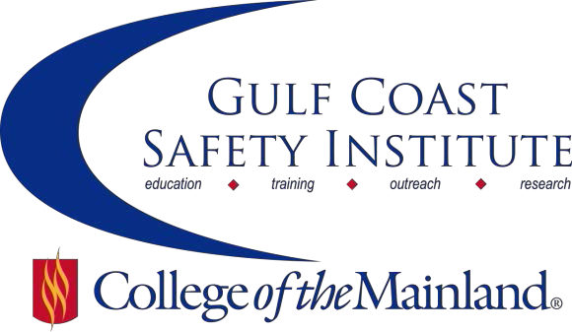

Center for Risk Management
2018 Fall Course Schedule
The Center for Risk Management safety training classes are offered FREE to the public through a generous grant from the Texas Mutual Insurance Company. All courses are scheduled to begin at 8:00 am on the dates listed. Courses are held at the Gulf Coast Safety Institute facility. All dates are on Fridays during the calendar year unless otherwise listed. Continuing Education Units (CEUs) and certificates will be awarded upon successful completion of each course. For more information, or to register, call 409-933-8365, email riskmanagement@com.edu, or visit www.com.edu/gcsi.

Introduction to the Department of Homeland Security Chemical Anti-Terrorism Standard – 8 hrs

The Chemical Facility Anti-Terrorism Standard has been in effect for five years and currently monitors over 3,300 facilities. There are more than 300 chemicals of interest categorized as possible security issues due to release, theft or diversion, or sabotage. On August 1, 2013, the federal government issued an Executive Order (EO) “Improving Chemical Facility Safety and Security” to improve the safety/security of chemical facilities and reduce the risks of hazardous chemicals to workers and communities. The EO established the Chemical Facility Safety and Security (Working Group)—tri-chaired by the Department of Homeland Security (DHS), the Environmental Protection Agency (EPA), and the Secretary of Labor—to oversee this effort. In response DHS created the Infrastructure Protection (IP) Gateway-a repository of critical infrastructure tools and information to improve coordination between Federal, State, local governments, and community stakeholders to strengthen the program. This course we will discuss: recognizing chemicals of interest; developing a compliance plan; interacting with DHS; adherence to common requirements to comply; costs and budgeting.

SAFE-1816-OSHT-1071-117CL 09/07/18 GCSI Rm 115 L. Mcgaha

The Art of Conflict Resolution– 8 hrs

Conflict resolution is a way for two or more parties to find a peaceful solution to a disagreement among them. The disagreement may be personal, financial, political, or emotional. Effective communication skills are paramount in conflict resolution in the workplace. In this course participants will learn effective communication strategies, understand how to resolve conflicts more effectively and discover how biases, assumptions, perceptions and opinions not based in reality causes conflict.

SAFE-1817-OSHT-1071-118CL 09/21/18 GCSI Rm 115 P. Harrell

Workshop on ISO-45001 Occupational Health & Safety Management– 8 hrs

ISO 45001, a global occupation health and safety management system standard, is intended to replace the widely implemented BS OHSAS 18001. It is anticipated that organizations currently certified to BS OHSAS 18001 will need to migrate to ISO 45001 within three years of the new standard’s publication. Having an internationally recognized occupational health and safety management system (OH&SMS) allows you to enhance organizational health and safety performance. Participants will obtain a detailed understanding of the key terms, definitions and requirements of ISO 45001 and how the standard can help their organization to better align their strategic direction with their occupational health and safety management system.

SAFE-1818-OSHT-1071-119CL 10/05/18 GCSI Rm 115 C. Litton

Regulated Waste Management and RCRA Updates– 8 hrs

Under the auspices of the RCRA - Resource Conservation and Recovery Act of 1976, the EPA was tasked with developing regulations regarding the proper management of waste materials that went into effect in 1980. These regulations have gone relatively unchanged for 37 years. In roughly a one-year period, the EPA is rolling two of most substantial changes the regulated community could have ever imagined. This course will address the basic requirements of waste management for a generator with particular emphasis on the changes brought about by the Generator Improvement Rule – GIR and E-Manifesting.

SAFE-1819-OSHT-1071-120CL 10/19/18 GCSI Rm 115 S. Laughlin

Incident Investigation– 8 hrs

An incident investigation is the account and analysis of an incident based on information gathered by a thorough examination of all causal and contributing factors involved. It gets to the root causes of the incident, so similar occurrences can be prevented and future losses in the workplace can be avoided. Investigations are conducted to meet legal compliance, but more importantly to help prevent reoccurrences. Therefore, it is essential to ensure those who are responsible for investigating incidents are properly trained. The objectives of this course will focus on techniques for gathering complete, accurate and objective incident data, how to conduct effective interviews, identifying causal and contributing factors, reporting findings and various tools and techniques for conducting an investigation. Additionally, we will discuss some common mistakes that companies often make when conducting incident investigations and how to avoid them.

SAFE-1820-OSHT-1071-121CL 11/02/18 GCSI Rm 115 B. Wehnes

Active Shooter Preparedness– 8 hrs

An active shooter is a person actively engaged in killing or attempting to kill people in a confined and populated area. Active shooter situations are unpredictable and evolve quickly. The purpose of this class is to prepare participants for an active shooter in the workplace. Participants will learn: how to recognize potential workplace violence indicators; actions to take when confronted with an active shooter; actions to take to prevent and prepare for potential incident; and how to manage the consequences of an active shooter incident.

SAFE-1821-OSHT-1071-122CL 11/16/18 GCSI Rm 115 C. Rosier

Crushing It: Leading As a High Performer– 8 hrs

Every organization wants their team to win and be successful. In order to create sustained results, we must possess leadership and high performance skills in order to move from strategy to execution. "Crushing It" combines key leadership and high performance skills that will accelerate your teams’ performance and increase your influence. Because creating results requires high performance skills. Creating sustained results requires leadership.

SAFE-1822-OSHT-1071-123CL 11/30/18 GCSI Rm 115 M. Hernandez

Nuts & Bolts of Industrial Hygiene– 8 hrs

By definition, industrial hygiene is the art and science of the anticipation, recognition, evaluation, communication and control of hazards in the workplace that may result in injury or illness. In practice, industrial hygiene is how we measure whether or not someone might get sick or hurt at their job. This class will cover the fundamentals of industrial hygiene and how to determine what the industrial hygiene program should look like at your facility.

SAFE-1823-OSHT-1071-124CL 12/07/18 GCSI Rm 115 T. Holowaty

Gulf Coast Safety Institute * 320 Delany Road La Marque TX 77568 * 409-933-8162

